FDT detritivorous fish blennies

Gut-content analyses of salariin blennies collected from the Great Barrier Reef reveals that these fishes pre- dominantly ingest detrital aggregates.

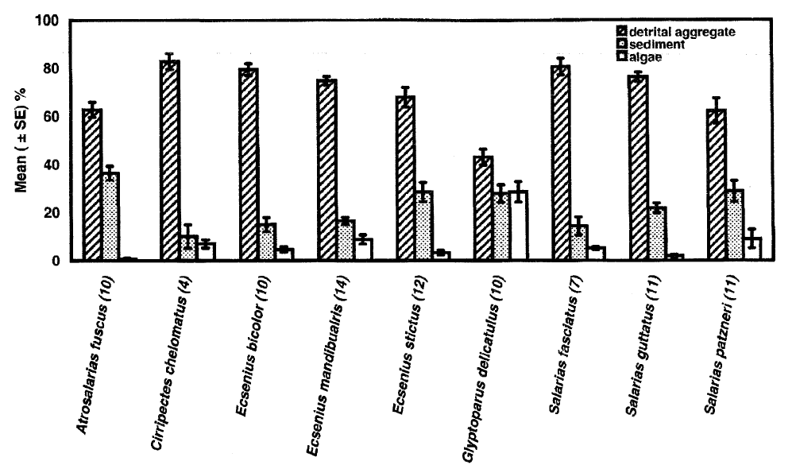

|  |  |
| --- | --- |
| **prey item** | **probability of consuming** |
| DR | 0.3 |
| DL | 0.3 |
| BAC | 0.3 |
| MI | 0.3 |

references:

Wilson, S.K. 2000. Trophic status and feeding selectivity of blennies (Blennidae:Salariini). Marine Biology 136, 431-437